INDIAN INSTITUTE OF TECHNOLOGY

KHARAGPUR

APPLIED COMPUTATIONAL METHODS LABORATORY

LAB 8 REPORT

Rajiv Harlalka

20MA20073

Department of Mathematics

OR ITERATIONS

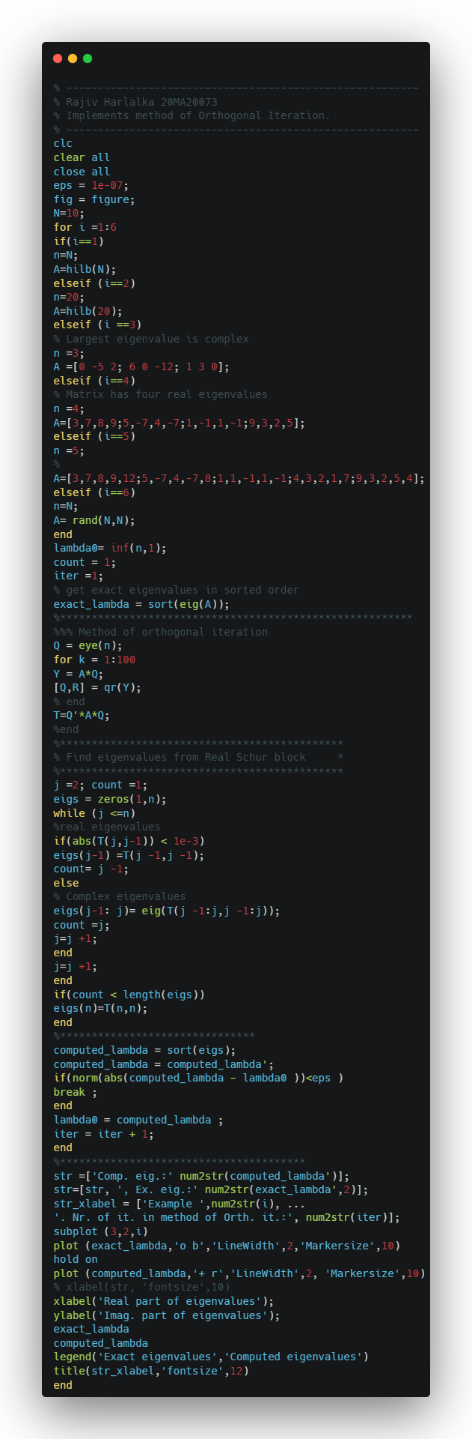Codes:

OUTPUT PLOT:

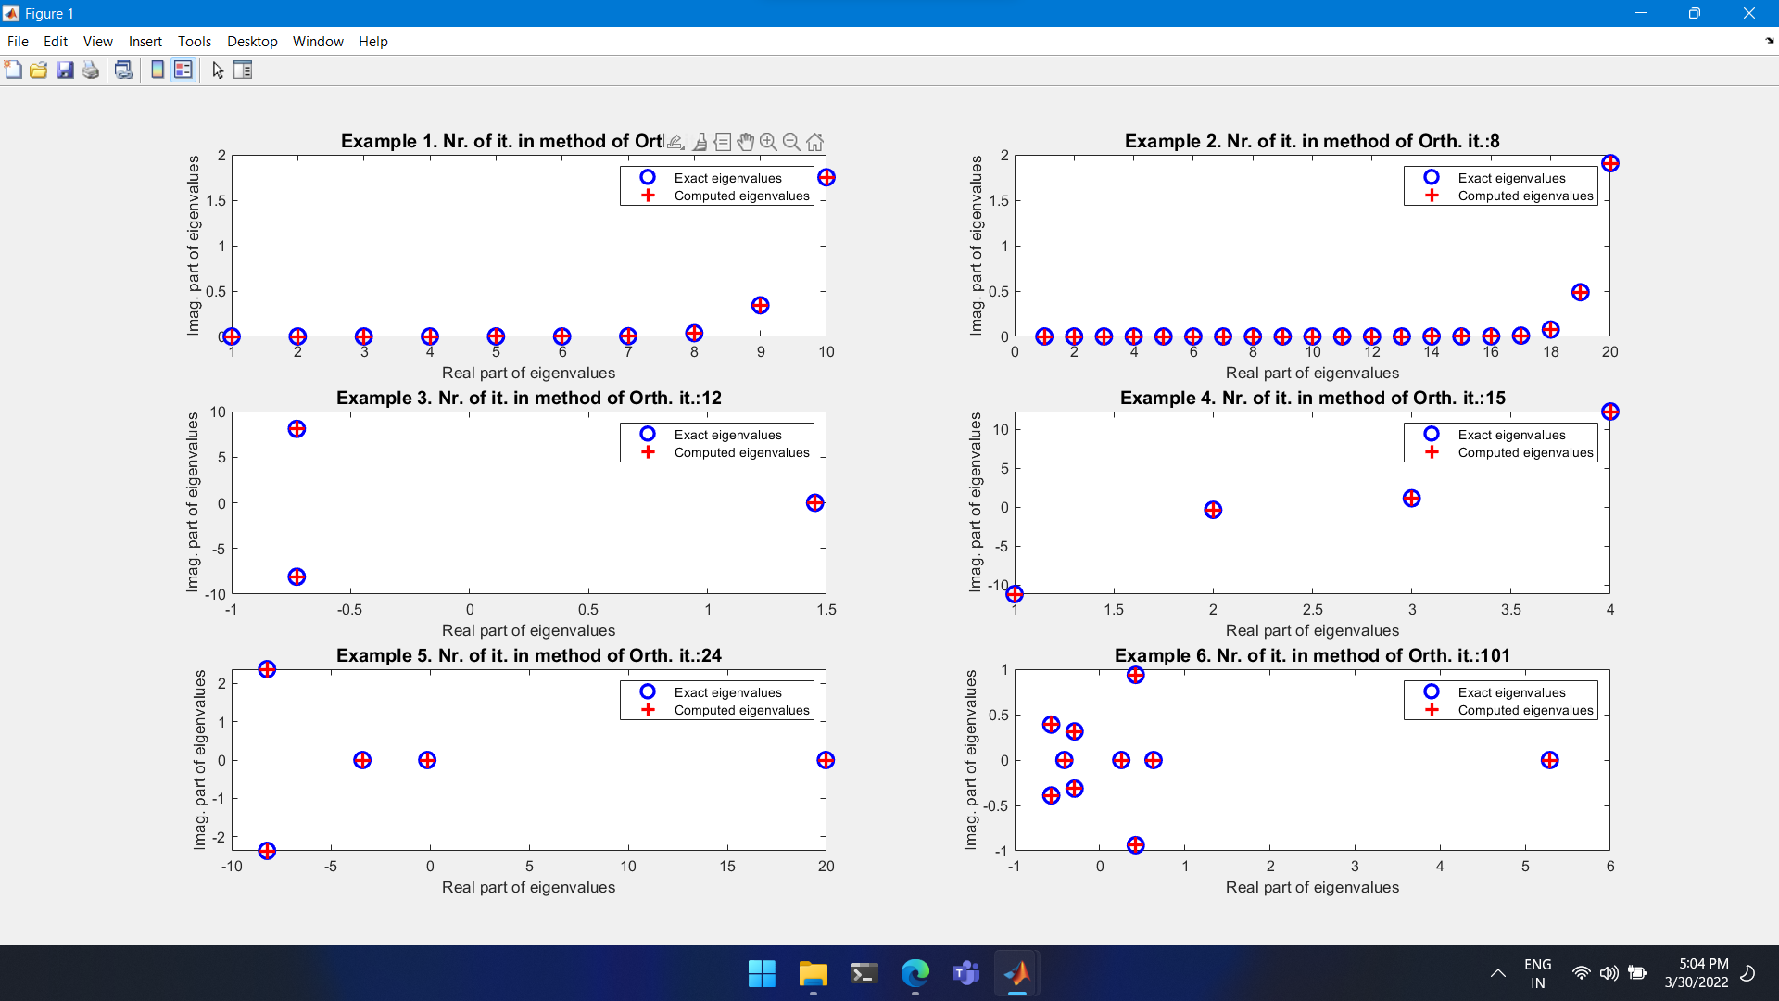

QR ITERATIONS

Code: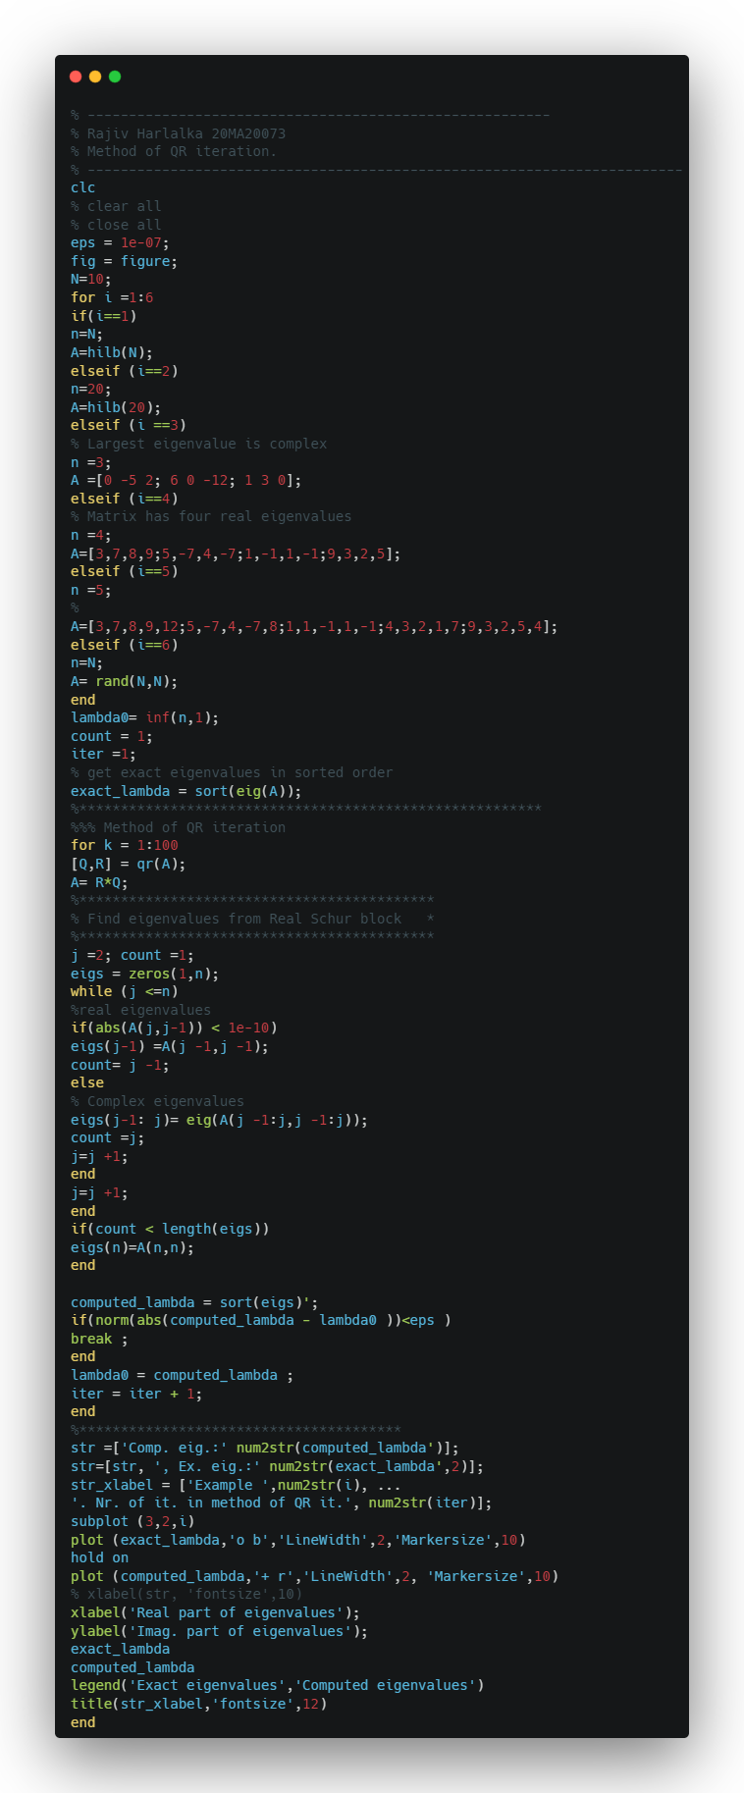

OUTPUT PLOT

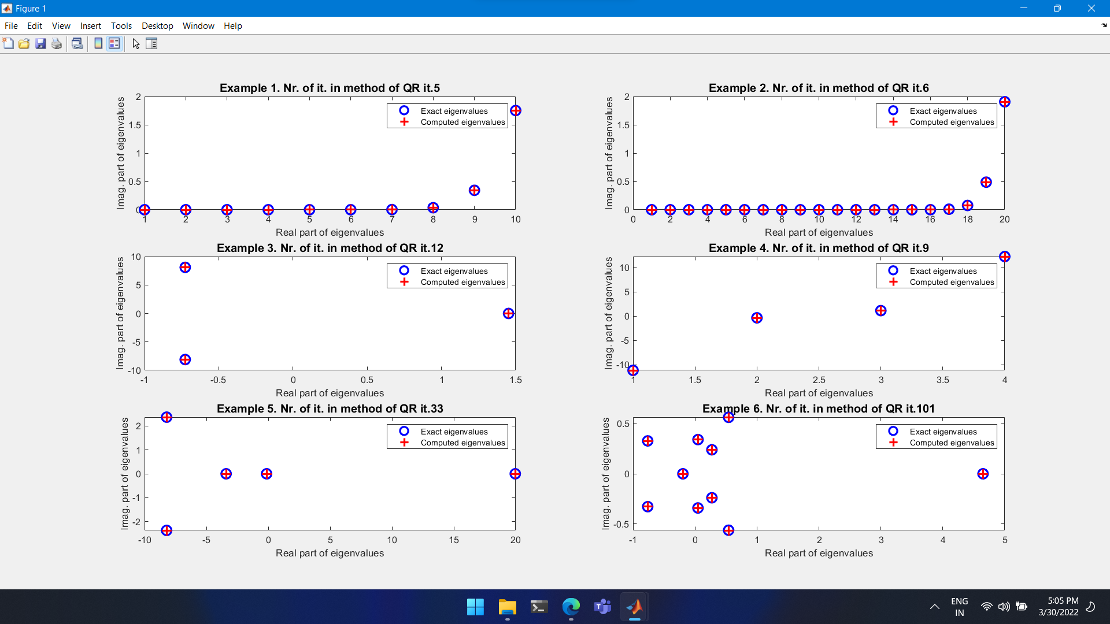

QR ITERATIOSN WITH SHIFTS

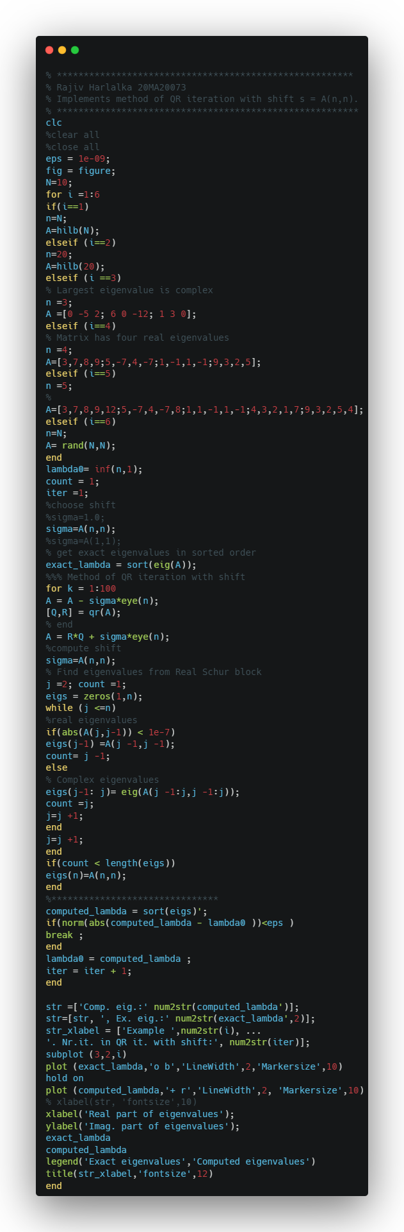Codes:

OUTPUT PLOTS

